**HIS INTERGRATION FOR PATIENT MOBILE APPLICATION**

1. **THE PURPOSE OF INTEGRATION:**

* To provide the information to patient via mobile application
* To improve the patient experience.

1. **REPORT SCHEMA:**
   1. **PERIOD TIME TRANSMISSION DATA: 1-way synchronization data (From HIS to Mobile app ONLY)**

**SYNCHRONIZE DATA BY 2AM GMT+7**

|  |  |
| --- | --- |
| **INFORMATION** | **STATUS IN REPORT SCHEMA** |
| Patient PRN & Patient NOK information | Yes |
| Vaccination history of patient | Yes |
| Patient who purchase vaccine package | Yes |
| Medical report (Doctor Note) | Yes, Need to generate PDF file |
| Vital signs | Not have available data in report schema |
| Revisit check up | Not have available data in report schema |
| Lab report | Yes, Tool auto sync to AWS is ready. |
| Image diagnosis | Wait for HPH IT |
| Radiology result | Yes, Need to generate PDF file |
| Patient RX | Yes, screen app |
| Patient Bill | Yes, screen app |

* 1. **Header information: ALWAYS IN THE HEADER OF DOCUMENT of PDF FILE**

**Table use: NOVA_PATIENT, NOVA_VISIT, NOVA_PATIENT_RX**

|  |  |  |
| --- | --- | --- |
| Information | Table | Columns |
| Patient name | Patient | PRN, PATIENT_NAME, TITLE, |
| PRN | Patient | PRN |
| Account No: (This is visit number: Each of time visit hospital, system create one account no.) | Patient & Visit | PRN, ACCOUNT_NO |
| Sex | Patient | GENDER |
| Age | Patient | DOB |
| Attending Doctor | Patient_Rx | ACCOUNT_NO, DOCTOR_NAME |
| Reg_ Date | Visit | REGISTRATION_DATE, REGISTRATION_TIME |
| VISIT TYPE | Visit | VISIT_TYPE |
| TYPE OF DOCUMENT:  MEDICAL REPORT – BỆNH ÁN  LAB REPORT – KẾT QUẢ XÉT NGHIỆM/ CHUẨN ĐOÁN HÌNH ẢNH  PRESCRIPTION – TOA THUỐC  INVOICE – HÓA ĐƠN |  | Note: DEPENDING ON EACH OF DOCUMENT, THE TITLE OF DOCUMENT IN THE HEADER WILL BE CHANGED ACCORDINGLY |

1. **DOCUMENT/ GENERATING PDF/ SCREEN APP**
   1. **PRN NUMBER AND RELATED PRN NUMBER: (MAPPING BETWEEN NOVA_PATIENT AND NOVA_PATIENT_NOK)**

**Table use: NOVA_PATIENT, NOVA_PATIENT_NOK**

|  |  |  |  |
| --- | --- | --- | --- |
| Information | Table | Columns | Mapping to Other Table / Columns |
| Patient name | Patient | PRN, PATIENT_NAME, TITLE, |  |
| PRN | Patient | PRN | Table: Patient_NOK  Column: PATIENT_PRN |
| NOK_ID (PRN OF RELATIVES: FORMAT: P-00022009 WITH P MEANS VIRTUAL PRN.) | PATIENT_NOK | NOK_ID |  |
| RELATION DESCRIPTION | PATIENT_NOK | RELATION_DESCRIPTION |  |
| PRN (PRN OF RELATIVES) | PATIENT_NOK | PRN |  |
| NAME OF RELATIVES | PATIENT_NOK | PATIENT_NOK_NAME |  |
| GENDER OF RELATIVES | PATIENT_NOK | GENDER |  |
| MARITAL STATUS OF RELATIVES | PATIENT_NOK | MARITAL_STATUS |  |
| DOB OF RELATIVES | PATIENT_NOK | DOB |  |
| NATIONALITY OF RELATIVES | PATIENT_NOK | NATIONALITY |  |
| HOME PHONE OF RELATIVES | PATIENT_NOK | HOME_PHONE |  |
| HOME ADDRESS OF RELATIVES | PATIENT_NOK | HOME_ADDRESS |  |

**NOTE: ONLY RELATIVES HAS PRN CAN BOOK APPOINTMENT. IF RELATIVES HAS VIRTUAL PRN, CANNOT BOOK APPOINTMENT.**

* 1. **VITAL SIGNS**

*Wait for hospital*

* 1. **VACCINATION:**
* Patient who purchased the vaccination package: table: NOVA_SERVICE

|  |  |  |
| --- | --- | --- |
| Information | Table | Columns |
| PRN | NOVA_SERVICE | PRN |
| Vaccine package | NOVA_SERVICE | SERVICE_CODE (Reference list of Vaccine Package.) |
| Vaccine | Reference list of Vaccine Package Excel file. |  |

* Patient’s vaccination schedule history: table: NOVA_RX

|  |  |  |
| --- | --- | --- |
| Information | Table | Columns |
| PRN | NOVA_VISIT | PRN |
| ACCOUNT NO | NOVA_VISIT | ACCOUNT_NO |
| EVENT | NOVA_RX | FILTER: DISPENSE ONLY |
| CODE | NOVA_RX | CODE.  Base on the list of code mentioned in NOVA_RX, record which type of vaccine is already vaccinated. |

File list of vaccine package and vaccine in the link: <https://drive.google.com/open?id=1MhDKNFsNWyrDdZMj3bq4rhkVhqukfgRu>

* 1. **MEDICAL REPORT: GENERATE PDF FILE FROM DATABASE**

**Table use: NOVA_PATIENT, NOVA_VISIT, NOVA_VISIT_SUMMARY**

**Mapping by ACCOUNT_NO**

|  |  |  |  |  |  |  |  |  |  |  |  |  |  |
| --- | --- | --- | --- | --- | --- | --- | --- | --- | --- | --- | --- | --- | --- |
|  | **MEDICAL REPORT**   |  |  |  | | --- | --- | --- | | Information | Table | Columns | | Account no | Nova_Visit_Summary | ACCOUNT_NO | | Medical report | Nova_Visit_Summary | CATEGORY_DATA | | Visit Type | Nova_Visit | Visit Type:  Outpatient  Inpatient |   Note: Filter: “Category” column in NOVA_VISIT_SUMMARY table:  Select only: Ch?n ?oán / Diagnosis  The data in CATEGORY_DATA is format HTML.  Template: Link: <https://drive.google.com/open?id=18X7JDo3u0cIPbX6YmSxUlCD1UI4dXZRt> |

* 1. **PATIENT PRESCRIPTION : SCREEN APP**

**Table use: NOVA_PATIENT_RX**

|  |  |  |  |  |  |  |  |  |  |  |  |  |  |  |  |  |  |  |  |  |  |  |  |  |  |  |  |  |  |  |  |  |  |  |  |  |  |
| --- | --- | --- | --- | --- | --- | --- | --- | --- | --- | --- | --- | --- | --- | --- | --- | --- | --- | --- | --- | --- | --- | --- | --- | --- | --- | --- | --- | --- | --- | --- | --- | --- | --- | --- | --- | --- | --- |
|  | |  |  |  | | --- | --- | --- | | **Information** | **Table** | **Columns** | | Order No: | Patient_Rx | ORDER_NO | | RX Ref No: | Patient_Rx | RX_REF_NO | | Event | Patient_Rx | Filter: Dispense ONLY | | Items Description | Patient_Rx | DESCRIPTION | | Instruction | Patient_Rx | EXPANDED_INSTRUCTION | | UOM | Patient_Rx | UOM | | Quantity | Patient_Rx | QUANTITY | | Duration |  |  | | Date and Time | Patient_Rx | Event Date & time | | Doctor | Patient_Rx | DOCTOR_NAME | | Date | Patient_Rx | EVENT_DATE |   **Note: Need to base on Account No to get the correct Patient RX for particular visit time.**  **SCREEN APP: IN NEW XD FILE UPDATE** |

* 1. **PATIENT INVOICE: SCREEN APP**

**Table use: NOVA_BILL, NOVA_ITEMS**

|  |  |  |  |  |  |  |  |  |  |  |  |  |  |  |  |  |  |  |  |  |  |  |  |  |  |  |  |  |  |  |  |  |  |  |  |  |  |
| --- | --- | --- | --- | --- | --- | --- | --- | --- | --- | --- | --- | --- | --- | --- | --- | --- | --- | --- | --- | --- | --- | --- | --- | --- | --- | --- | --- | --- | --- | --- | --- | --- | --- | --- | --- | --- | --- |
|  | |  |  |  | | --- | --- | --- | | Information | Table | Columns | | PRN | NOVA_BILL | PRN | | Note: Filter: BILL_TYPE | NOVA_BILL | BILL_TYPE: Choose: MAIN | | ACCOUNT NO | NOVA_BILL | ACCOUNT_NO | | INVOICE NUMBER | NOVA_BILL | INVOICE_NO | | BILL DATE | NOVA_BILL | BILL_DATE | | BILL NUMBER | NOVA_BILL | BILL_NO | | ITEMS | NOVA_ITEMS | MAPING WITH BILL_NO | | ITEMS PRICE | NOVA_ITEMS | FINAL_AMOUNT | | ITEMS QUANTITY | NOVA_ITEMS | QUANTITY | | UOM | NOVA_ITEMS | UOM | | TOTAL AMOUNT | NOVA_BILL | AMOUNT |   **SCREEN APP: IN NEW XD FILE UPDATE** |

* 1. **IMAGE INVESTIGATION AND LAB TEST**

**For lab test: THERE IS TOOL TO AUTO-SYNC LAB REPORT TO AWS SERVER.**

**For Radiology image: THERE IS TOOL TO AUTO-SYNC LAB REPORT TO AWS SERVER.**

**For Radiology result: NEED TO GENERATE PDF FILE, AND AUTO-SYN TO AWS SERVER**

**Table use: NOVA_PATIENT_INVESTIGATION & NOVA_PATIENT_INVESTIGATION_DET**

**Picture 15: Lab test**

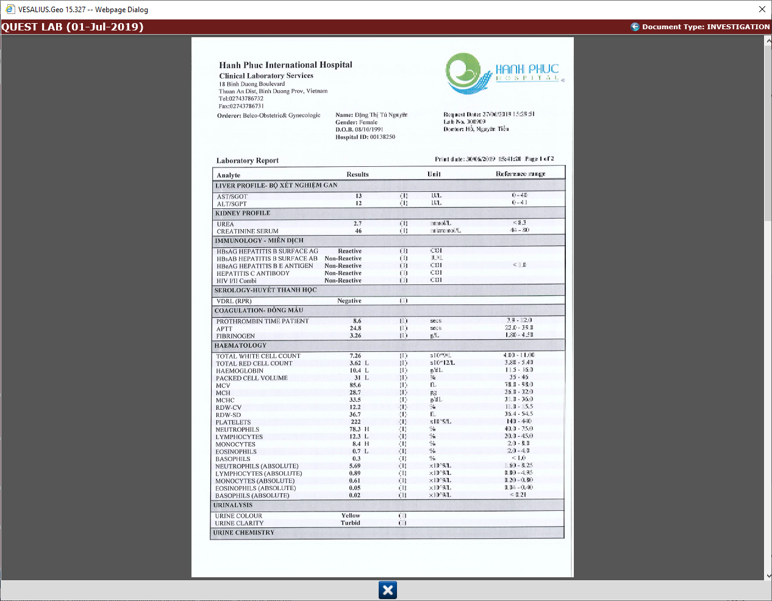

**Radiology**

**Table use: NOVA_PATIENT_INVESTIGATION & NOVA_PATIENT_INVESTIGATION_DET**

|  |  |  |  |  |  |  |  |  |  |  |  |  |  |  |  |  |  |  |  |  |  |  |  |  |  |
| --- | --- | --- | --- | --- | --- | --- | --- | --- | --- | --- | --- | --- | --- | --- | --- | --- | --- | --- | --- | --- | --- | --- | --- | --- | --- |
|  | |  |  |  | | --- | --- | --- | | Information | Table | Columns | | PRN | NOVA_VISIT | PRN | | Account No | NOVA_VISIT | ACCOUNT_NO | | Report Number | Nova_Patient_Investigation | INVESTIGATION_REF_NO | | Type of report | Nova_Patient_Investigation | INVESTIGATION_TYPE:  Filter: Radiology Services | | Request date | Nova_Patient_Investigation | ORDER_DATE | | Date | Nova_Patient_Investigation | START_DATE | | Result | Nova_Patient_Investigation_Det | RESULT_CLOB |   Result in HTML format  Map table: Nova_Patient_Investigation with table Nova_Patient_Investigation_Det by INVESTIGATION_REF_NO  Template: Link: <https://drive.google.com/open?id=18X7JDo3u0cIPbX6YmSxUlCD1UI4dXZRt> |